“JARVIS: A PORTABLE AI ASSISTANT”

Dr.T.V.Divya  Assistant Professor, Dept of CSE,  Sreyas Institute of Engineering  And Technology, Telangana, India. tv.divya@sreyas.ac.in  Boddu Lavanya  Dept of CSE, Sreyas Institute of  Engineering and Technology,  Telangana, India.  boddulavanya@gmail.com | Chinthakuntla Uday  Dept of CSE, Sreyas Institute of  Engineering and Technology,  Telangana, India.  wolverineuday@gmail.com  Varakala Varun Raj  Dept of CSE, Sreyas Institute of  Engineering and Technology,  Telangana, India. Varunrajvarakala2004@gmail.com | Nampalli Shilpa  Dept of CSE, Sreyas Institute of Engineering and Technology, Telangana, India.  nampallishilpa@gmail.com

Abstract— This project presents JARVIS: A Portable AI Assistant, a lightweight voice-controlled system designed to run directly from a USB pen drive across multiple platforms including Windows. The assistant combines both offline and online capabilities, enabling users to perform everyday tasks such as file management, media control, document reading, message replies, and intelligent web-based information retrieval. JARVIS utilizes speech recognition and text-to-speech technologies to enable natural human–computer interaction through voice commands. The system continuously listens for predefined wake words while running silently in the background, ensuring hands-free operation. Its conversational AI model provides real-time responses and task execution without requiring extensive setup on host systems. The portability, platform independence, and autonomous functioning of JARVIS make it an innovative and practical solution for personalized digital assistance, inspired by the concept of Iron Man’s intelligent assistant.
Keywords— Portable AI Assistant, Voice Recognition, Speech-to-Text, Text-to-Speech, Cross-Platform Application, USB-Based Computing, Conversational AI, Virtual Assistant, Natural Language Processing, Task Automation

Introduction
Artificial Intelligence has changed the way we interact with digital platforms. Voice interfaces are becoming a keyway for people to interact because they allow users to speak naturally and are easier and quicker to use. Siri, Google Assistant, Alexa, and Cortana are examples of voice-based virtual assistants that use speech recognition and natural language processing to help users work efficiently [1]. Unfortunately, they rely on clouds, are tied to certain platforms, and are heavily connected to closed systems. Using cloud-based systems can lead to several issues for users, such as solving these issues [2]. This study introduces JARVIS: A Portable AI Assistant. It is a simple, USB-powered, voice-controlled tool that works without the need to install anything on the main device.
JARVIS is different from regular assistants because it keeps all its settings on the user’s device and does most of the work without needing the Internet, which means it uses less of the cloud and offers better privacy [3].
When the Internet is not working, it still performs tasks such as moving files, opening programs, controlling music or videos, and reading documents. When connected to the Internet, it provides smart web-based searches and talks back in a conversation-like manner [11][12]. The assistant works silently in the background all the time, and it only starts working when it hears the special word that is chosen. This method helps to use resources well and makes it easier for the user. JARVIS is a helpful digital assistant because it is easy to carry around, keeps your information private, is designed to help you focus, and works well with different computer systems. This makes it great for students, people working in offices, and everyday use on a computer.

II. System Architecture And Design
The system architecture of JARVIS: A Portable AI Assistant is geared to establish a neatly arranged and effective layout that allows uninterrupted communication between the user and the computer using voice commands. The architecture is based on a modular design concept where the different elements of the system are split into separate functionally running modules. Each module is responsible for a particular function like voice input capturing, command processing, system operation execution, and response generation [5]. Moreover, this modular architecture makes sure that the system can be very flexible, easily maintainable, and the upgrading process becomes hassle-free.
By segmenting the assistant into several mutually connected levels, the design mode accommodates that each element runs individually but, at the same time, contributes to the overall assistant operation flow.
The input layer is the first component of the overall architecture, and it oversees taking voice commands from the user. A microphone is employed by the assistant to record audio signals, and it is kept on the lookout for a wake word, like "Jarvis, " which is a word that signals that the user is addressing the assistant. The wake-word spotting feature is indeed a crucial element of the architecture as it shields from the system from incessantly running processing operations on superfluous audio inputs. In fact, the assistant simply "hears" in a passive mode until the utterance of the activation word is detected. The recording of the user's voice command is started by the system as soon as the wake word is detected, and the audio signal is sent to the speech processing module. In this manner, the design upgrade provides the assistant with greater efficiency by a reduction of the processing work and by guaranteeing that the system is only alive when there is a genuine need for it.
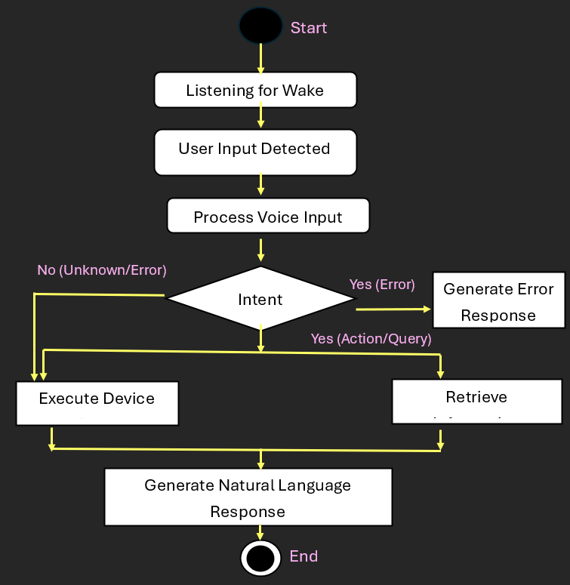
Fig 1: Command Processing

Once the system figures out the user's intent, it sends the request over to the task execution layer. This layer is the part of the system that executes or carries out the requested operation. It communicates with the operating system and different software applications to perform activities like launching a program, finding a document, changing system configurations, or playing a media file. Moreover, architecture is designed to have the ability to fetch information from external sources whenever it is required. So, if the user requests some information that can only be accessed via the Internet, the assistant will be able to connect to online services or databases to get the right data. However, the system is built in such a way that it can still function without Internet access, offering many features that do not require connectivity, which means that the assistant can still be of great help even if the user is in a place with weak or no Internet connection [6].

Portable is a main design trait of JARVIS's architecture. Most virtual assistants nowadays depend on cloud-based services, but JARVIS can really function from a portable storage medium like a USB drive. All the programs, libraries, and configuration files are stored in a portable environment. The assistant can be run on separate computers without the need for installation or long setup processes. Also, it is the local system that mainly carries out the processing tasks, so this architectural feature not only safeguards privacy but also lessens reliance on external servers.

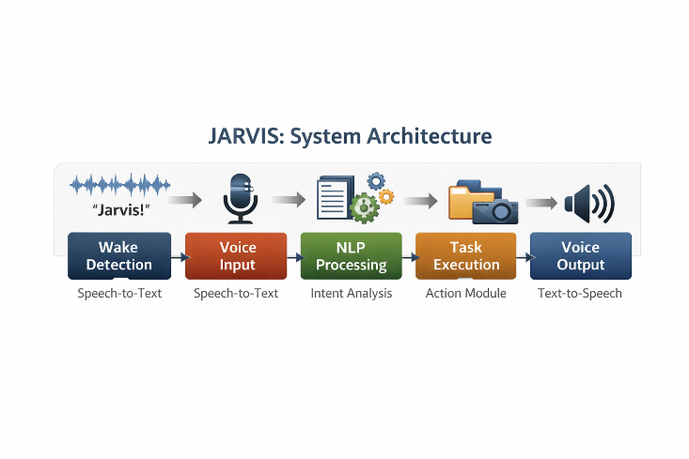
Fig 2: System Architecture

Overall, the architecture of the JARVIS system effectively integrates voice recognition technology and natural language processing with task automation in a well-planned framework [9]. The emphasis of the design is on efficiency, portability, and user-friendliness, so that using voice commands to control computers is reliable and comfortable for users. Also, the modular structure is a great advantage for adding new features in the future, e.g. better AI, multi-language support, and connection with smart devices or Internet of Things platforms.

III. Implementation And Working Mechanism
The aim of launching JARVIS: A Portable AI Assistant is to create a robust, very compact, and very easy-to-use voice interaction system capable of running right out of a portable storage device (for example, a USB flash drive). The backbone of this system is primarily built on the Python programming language as it provides a rich set of AI, automation, and speech-processing libraries [7]. Python has been selected mainly because it is easy to learn and use, very flexible, and it has a lot of very potent libraries that simplify the tasks of voice recognition, natural language understanding, and automation of functionalities via voice [7]. The whole application has been developed in a modular way. Each module is a self-contained unit of the system performing independent and unique functions, e.g. voice input handling, command analyzing, task performing, and answer generating. Such arrangements of modules not only make the assistant simple to test, debug, and maintain but also allows the assistant to be expanded easily in the future.
The initial step in the implementation process is to capture the user's voice input through a microphone interface. While running in uninterrupted mode in the background, the system listens to a preselected wake word, e.g. "Jarvis" that would serve as the activation trigger. This wake-word detection method prevents the assistant from being activated unnecessarily and thus saves CPU time and system resources [5]. On finding the wake word, the system turns on the command recognition part and starts recording the speech command from the user [4]. The recorded sound is then passed through the Speech Recognition library which transforms voice to text using speech-to-text conversion techniques. This conversion is essential because it changes human speech into computer-readable text that can be analyzed further by the system [9].
Once the speech gets changed into text, the command will be sent to the Natural Language Processing (NLP) component. This part studies the form and significance of the user's formulation by techniques like extraction of the main words, breaking down into small parts, and recognizing the goal. The objective at this stage is to find out the user's motive and group the request into categories of system control, running apps, getting info, or simple talk responses. Recognizing the purpose behind the order, the system will know what kind of action to take. The NLP component is like the brain of the assistant, making sure that the requests are understood accurately even when the users express them in a bit different ways.
After the system understands the user's intention, it sends the command to the task execution module that carries out the work. The module is directly engaged with the operating system and the application programming interfaces to fulfill the tasks such as running a program, searching files, playing media, or issuing system-level commands. Besides, the assistant can get information from the web if it is connected to the internet. For instance, it can conduct web searches, get information on Wikipedia for questions, or obtain data from external APIs. More importantly, many of the JARVIS core functionalities are built to run in an offline mode, which means that users can still control the system, handle files, and launch applications even if they are not connected to the Internet. The mixing of both online and offline capabilities leads to the reliability of core JARVIS functionalities and enables users to control their system, manage files, and run applications even without relying on an internet connection [10]. This hybrid approach increases the reliability and usability of the assistant in cases when the internet is not always available.
After successfully performing the requested task, the system makes a suitable response ready to inform the user about the result. The response is first created in a text format and then converted into speech by a TTS (Text-to-Speech) engine, like the pyttsx3 library. This part gives the assistant the possibility to talk back, thus making communication between the user and the system more natural and interactive [4]. The TTS engine also supports modification of the voice's speed, pitch, and tone so that the responses are not only clear but also easy to understand. Upon the completion of the response, the assistant goes back to the background listening mode and is ready for the yet-to-be-activated command. Another significant facet of the implementation is the portability of the system's execution. As a portable assistant is the goal of the project, all the necessary program files, dependencies, and configuration settings are placed inside a USB device. This way, the assistant can be operated on different computers without the need for installation on the host system. By keeping all data locally within the portable storage device, the system provides much better privacy and security in comparison with cloud-based assistants. Besides, the compact design has the least memory and processor requirements, which makes it possible for the assistant to keep running smoothly even on the moderately powered systems.
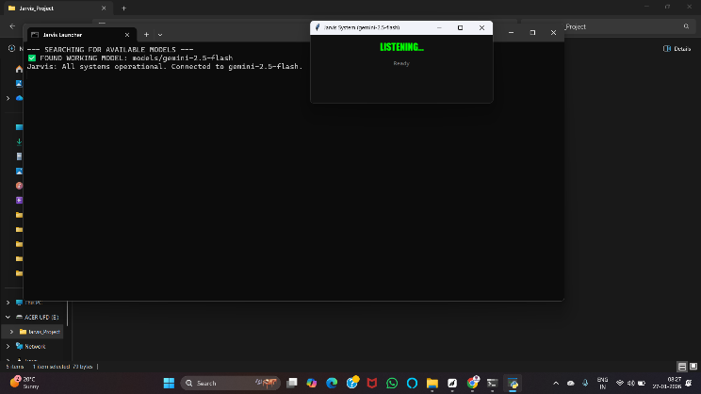

Fig 3: JARVIS System Interface

After the assistant finishes the task, a text message is created that includes a short summary of what was done, and a spoken version of that summary is created. The assistant switches back to a non-interactive state and is ready to respond again when it hears the next wake word. Our performance testing results show that the system uses very low amounts of CPU and memory when it is at rest as well as when it is active. Moreover, the average response time is so fast that it does not cause any kind of interruption in the flow of the conversation. Our portable deployment method enables the assistant to run on various machines without the need for further installation, and at the same time, it saves user preferences and configurations in the USB environment. This implementation approach guarantees high functionality, secure data management, and robust operation across a wide range of computer environments. Another essential aspect of this system is the ability to perform tasks in a portable manner.

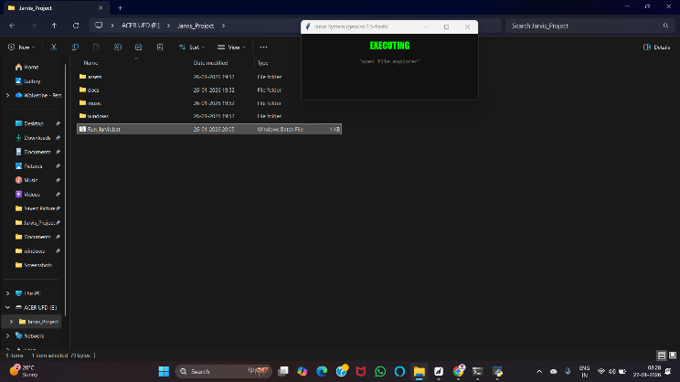
Fig 4: JARVIS Executing Voice Command
JARVIS, being a portable system that can operate from a USB storage device, encapsulates all the necessary files, libraries, and configurations within the portable environment. Hence the virtual assistant can be operated on various computers without the main program having to be installed on each of them. Through local data and process retention, this system in a way protects privacy and security better than cloud-based assistants that depend on remote servers.
Therefore, it can perform tasks such as starting programs, finding folders, running software, or adjusting system settings, even when there is no Internet connection. When working online, the assistant uses web APIs or Internet databases to find information and displays it to the user.

IV. Performance, Usability, And Advantages
The performance of JARVIS: A Portable AI Assistant was assessed based on the following criteria: the ability to respond swiftly to voice commands, the capability to function seamlessly on various operating systems, and the efficiency in carrying out user commands. Given that the assistant is intended to operate from a portable storage device like a USB drive, a major aim in the development process was to keep it very light and have it use minimal system resources. When put to the test, the assistant could be left running in the background for a long time without a tangible drop in the performance of the computer it was running on. The system is equipped with a wake-word recognition feature that picks up the user's predefined keyword and wakes the assistant from a low-resource listening state [2]. This method greatly minimizes processing and makes sure that the assistant stays highly responsive without a heavy processor or memory load.
One more aspect of a good performance is the speed and accuracy of voice recognition. Speech-to-text part is the one that changes spoken words into text, and how well it works determines how fast the assistant understands and answers a user's request. In real tests, the assistant recognized understandable voice commands with great precision and gave answers within seconds. Combining natural language processing with this function enhances the results even more by allowing the system to understand the meaning of commands instead of just using keywords [9]. This makes communication easier and more natural, so users can talk to the assistant in a more casual way.
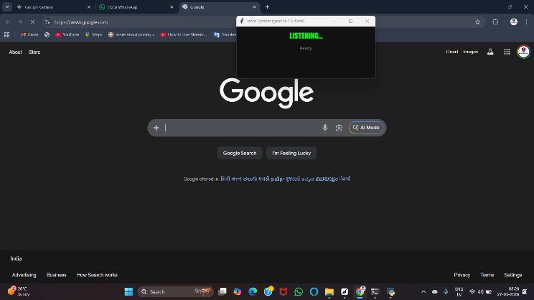
Fig 5: JARVIS in Listening State

JARVIS, at its core, is all about making things simple and handy for everyday use. It doesn't need the user to go through elaborate setup or installation processes, so it's quite straightforward to operate the assistant on different machines. Given that it is operated straight from a USB stick, users' can literally have their personalized helper with them and run it on various computers without encountering the hassle of setup each time. This feature of being on-the-go is beneficial for students, professionals, and even researchers who are always changing their workstations. Additionally, the voice interaction system makes it easier for the users as the only tool they need to give commands is their voice, so no keyboard or mouse is necessary. Getting the assistant to do your work while you are away from the keyboard or mouse can even make you save time and at the same time, certain operations might be a lot handier to do in this manner, especially if one is a multitasker.

Another point that enhances usability is the assistant’s proficiency in handling offline as well as online features. Some typical virtual assistants depend mostly on internet access, which restricts their functionality when the user is in the place where the network is unstable or the user can get a network at all. JARVIS, on the other hand, tackles this problem by characters the main offline features opening apps, managing files, controlling media, and performing system commands. If there is an internet connection, the assistant can broaden its features by being capable of doing web searches, extracting information from online sources, and answering users' questions. This mode of operation fully guarantees that the assistant remains operative and trustworthy in various scenarios [8]user.
JARVIS has several advantages over traditional virtual assistants, and they become more obvious only when the two are compared. The first, and perhaps the most significant, benefit is enhanced privacy and security. Currently, many assistants handle user data on remote servers, so many people are wondering how the personal information and voice recordings are stored and how they are being used. JARVIS is different, as it does most of its processing locally and stores data within the handheld device. This way, the transmission of private data over the internet is minimized, and the users are given more control over their data. Another benefit of local processing is quicker response times since there is no need to send commands to external servers for analysis. Besides, the system is lightweight and very adaptable. The assistant was developed with Python and modular components, which allows it to be changed or upgraded very easily to add new features in the future.

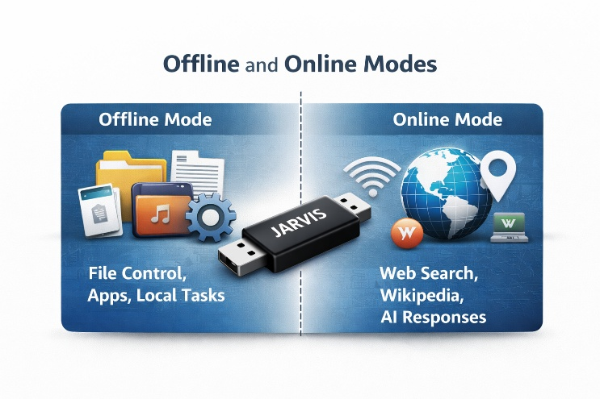
Fig 6: Offline and Online modes infographic

REFERENCES

[1] Stephanie (2018), Voice & Assistants, Introduction to intelligent personal assistant Alexa, Cortana Intelligence, Google Assistant, Apple Siri.
[2] Artificial intelligence, AI effect, Understanding Human Speech https://en.wikipedia.org/wiki/Artificial_intelligence
[3] M. Mirthula (2020), How to build your own AI. https://towardsdatascience.com/how-to-build-your-own-ai-personal-assistant-using-python-f57247b4494b Accessed 22 Dec 2020.
[4] Paul Taylor (2009), Text-to-speech Synthesis, Synthesis by concatenation and signal processing modification, 1st Edition. https://onlim.com/en/introduction-to-intellligent-personal-assistants
[5] Lawrence R Rabiner, B H Juang (1993), Englewood Cliffs, N.J.: PTR Prentice Hall, Basic plans of speech - Speech Recognition process, Fundamentals of Speech Recognition.
[6] Alan D. Moore, B. M.Harwani (2019), Building GUI: Python GUI Programming, Powerful GUI Applications with PyQt and Tkinter, 1st Edition, GUI using Tkinter pp 24–41.
[7] Al Sweigart (2015), Workflow by using Automation: Automate the Boring Stuff with Python, 2nd Edition: Practical Programming for Total Beginners.
[8] Artificial Intelligence Future Scope, Streamlined, Voice push notifications & Security reasons. https://clearbridgemobile.com/7-key-predictions-for-the-future-of-voice-assistants-and-ai/
[9] Develop Language modeling for ―Virtual Assistant‖, Deep Learning for Natural Language Processing. https://machinelearningmastery.com/develop-word-based-neural-language-models-python-keras/
[10] Rekha (2019), Edureka Artificial Intelligence for beginners.
https://www.youtube.com/watch?v=JMUxmLyrhS
[11] T. V. Divya, “An adaptive word vector integrated with enhanced LSTM for classification of fake news,” Journal of Cybersecurity and Information Management, vol. 15, no. 1, pp. 298–313, 2024. Proceedings of the International Conference on Pervasive Computational Technologies (ICPCT), 2025.
[12] T. V. Divya, “Convolutional neural networks for secure and efficient cubic equation solving,” in Proceedings of the 3rd International Conference on Sustainable Computing and Data Communication Systems, 2025.

